Assignment 3: System Design & Architecture Documentation

Student: Koshikov Alimzhan
Group: CSE-2501M
Task 1. Non-Functional Requirements & Trade-offs
Non-functional requirements (NFR) define the architecture, not the other way around. Before drawing any diagram, you must know the constraints that will drive your design decisions.

1.1. Define your NFR targets
Complete the table below for your specific project. Every cell must contain a concrete, measurable value, not a vague description.

Quality attribute | Target (numeric) | Measurement method | Justification
Latency | P95 mentor response < 1200 ms in template mode; P95 < 4000 ms with LLM enabled | interaction_logs.total_latency_ms, API tests | Feedback must feel immediate while the student is still focused on the code.
Analyzer latency | P95 < 250 ms for beginner code under 200 lines | Service tests around AnalyzerService | Analysis runs before policy selection, so it must stay lightweight.
Availability | 99.0% during class/demo periods | Uptime checks | This is a university prototype, so it should be stable during planned use.
Throughput | 30 concurrent students, 2 feedback requests per student per minute | Concurrent REST/WebSocket load test | This matches a small programming class.
Consistency | Strong consistency for users, tasks, sessions, and logs | Transactional tests, database constraints | Logs are research data and must be traceable to the exact session and attempt.
Data durability | RPO < 24h, RTO < 2h | Backup/restore check | Losing all interaction data would damage the evaluation part of the project.
Security | 100% protected write endpoints require JWT; task creation is teacher/admin only | MockMvc/security tests | Students must not access teacher/admin-only actions.
Maintainability | Core backend line coverage >= 80%; full backend line coverage >= 60%; CI must pass | JaCoCo + GitHub Actions (CI/CD) | The system is still evolving, so regressions must be visible early.
ML fallback reliability | 100% fallback to rule policy when ML fails and fallback is enabled | Unit tests for MentorPolicyService | ML is experimental and must not block the tutoring flow.
Observability | 100% completed mentor calls create an interaction log | Service tests and DB checks | The project depends on logs for evaluation and dataset export.

1.2 Identify your primary trade-off

Trade-off axis | What you optimize FOR | What are you willing to give up
Latency vs Throughput | Fast feedback for class-sized usage | Global-scale public traffic
Consistency vs Availability | Reliable logs, sessions, users, and tasks | Continuing silently during DB failure
Cost vs Performance | Low-cost template/rule baseline | Always-on premium LLM calls
Feedback detail vs control | Safe actions: CODE_HIGHLIGHT, CONCEPTUAL_HINT, GUIDING_QUESTION, NO_FEEDBACK | Fully open-ended chatbot behavior with opportunity to intervent by teaching staff

The main trade-off is latency and reliability vs. feedback detail. A pure LLM mentor could sound more natural, but it would be slower, less predictable, and harder to control pedagogically. A pure rule system is fast and safe, but can be repetitive. Socrates AI chooses a hybrid approach: deterministic analysis and policy first, optional LLM phrasing second and also provides opportunity to invervent by teaching staff.
Task 2. High-Level Architecture Diagram (C4 Model - L1 & L2)

Level 1 - System Context diagram
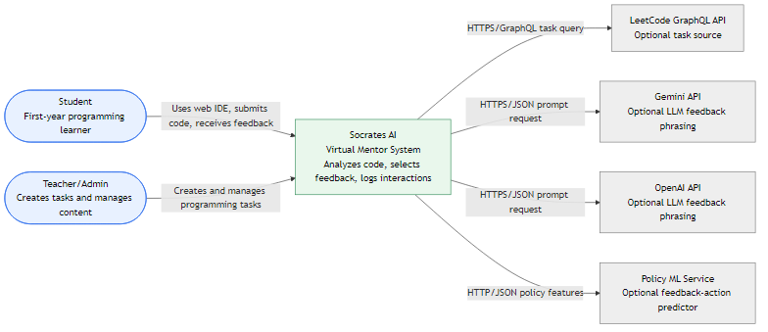

Level 2 - Container diagram
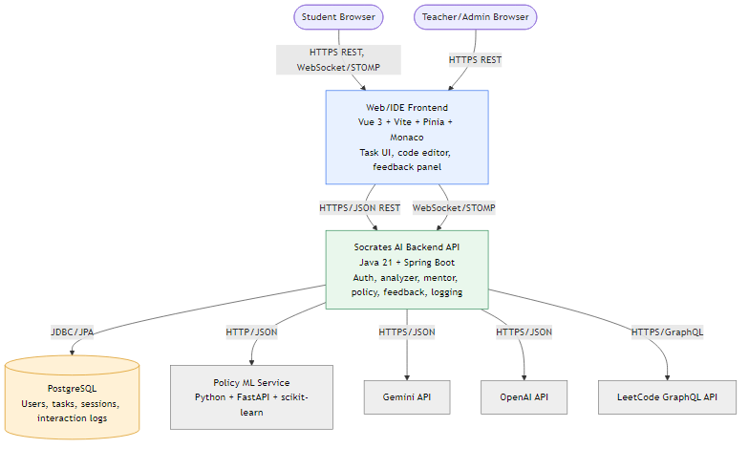

Task 3. Architecture Decision Record (ADR)

ADR template (fill in each section)
ADR-001 | Use a modular Spring Boot backend with an optional external ML policy service
Status | Accepted
Date | 2026-04-20
Context | Socrates AI combines authentication, task management, code analysis, session tracking, feedback policy, feedback generation, interaction logging, and ML experimentation. These parts could be split into many microservices, but that would add deployment and consistency complexity before the educational workflow is fully proven.  The system also needs traceability. A mentor response must be connected to a session, attempt number, analyzer result, policy action, feedback source, and interaction log. Keeping this path inside one modular backend makes the system easier to test and reason about.  At the same time, the ML part naturally belongs in Python because the training pipeline uses pandas, scikit-learn, FastAPI, and joblib artifacts. Putting this directly into the Java backend would make both sides less clean.
Decision | Socrates AI uses a modular monolith backend in Java 21 and Spring Boot, also it has package boundaries for analyzer, mentor, mentor/policy, mentor/feedback, interaction, session, auth/security, task, and user, separate optional Python/FastAPI ML policy service, rule-based fallback inside the backend, PostgreSQL as the durable and reliable relational database.
Rationale | This fits the NFRs because most mentor decisions can be made inside the backend process, which keeps latency low. It also keeps reliability acceptable because the backend can still select feedback through rules when ML is down. The modular monolith is simpler to test locally than a distributed system, but it still keeps the code organized by responsibility. ML can evolve separately without forcing the Java backend to become an ML runtime.
Alternatives rejected | - Full microservice for each module  Reason: Too much deployment, network, and data consistency complexity for the current project size.  - Single LLM chatbot backend  Reason: Easier to prototype, but weak on traceability, latency, pedagogical control, and reproducibility.  - Java backend directly loading the ML model  Reason: Reduces a network call but mixes Java application concerns with Python ML tooling.
Consequences | This approach makes local development and testing much easier. It is also simpler to trace how the mentor works step by step, from analysis to feedback. Another benefit is that we can cover analyzer, policy, feedback, and interaction logging with automated tests more consistently. Also, if the ML model or LLM provider fails, the system still has fallback behavior, so it does not fully break.  At the same time, some things become harder. It is less flexible for independent scaling of internal backend parts, because everything is still inside one main backend structure. There is also a risk that the modular monolith can slowly become messy if boundaries are not controlled well. One more challenge is keeping the contract between Java and Python ML service synchronized, because even small changes in request or response format can cause problems.  As follow-up actions, it is important to keep package boundaries clear and not let modules mix too much. We should also continue enforcing coverage gates for the core backend so quality does not drop. In addition, it would be good to add contract tests for the ML API to catch integration issues earlier. For LLM-based feedback, it is safer to keep generation behind template-based fallback, so even if the model response is bad or unavailable, the system can still return safe feedback.

Task 4. Detailed Component Design

Web/IDE Frontend
Component name | Web/IDE Frontend
Purpose | Student and teacher UI for coding tasks, authentication, and feedback display.
Responsibilities | Show tasks; provide Monaco-based editor; send code to backend; display feedback action, message, and suspicious region; store JWT session state.
Inputs | User edits and actions. Example mentor payload: { "studentId": 1, "taskId": 12, "language": "java", "code": "for (...) {}", "attemptNo": 2 }.
Outputs | Rendered task view, feedback panel, login state, API error messages.
Dependencies | Backend REST API and WebSocket/STOMP endpoint.
NFR sensitivity | Latency and usability. Feedback must appear quickly enough to remain useful.

Socrates AI Backend API
Component name | Socrates AI Backend API
Purpose | Main application boundary for auth, tasks, mentoring workflow, persistence, and integrations.
Responsibilities | Expose REST/WebSocket endpoints; enforce JWT security; orchestrate analyzer/policy/feedback/logging; persist data through JPA.
Inputs | /api/auth/login,  /api/tasks,  /api/mentor/analyze-feedback,  /api/interactions/policy-dataset,  /app/code.update.
Outputs | AuthResponse, TaskResponse, MentorResponse, CSV dataset export, HTTP errors.
Dependencies | PostgreSQL, ML service, Gemini/OpenAI, LeetCode API.
NFR sensitivity | Reliability and maintainability because most business behavior lives here.

Authentication and Security Module
Component name | Authentication and Security Module
Purpose | Register users, authenticate users, issue JWT tokens, and protect endpoints.
Responsibilities | Hash passwords; validate login; generate JWT; load security user details; restrict teacher/admin actions.
Inputs | RegisterRequest, LoginRequest.
Outputs | AuthResponse with token and user profile; errors for duplicate email, invalid credentials, invalid role, or missing token.
Dependencies | UserRepository, PasswordEncoder, AuthenticationManager, JwtService.
NFR sensitivity | Security. Incorrect authorization would expose teacher-only operations.

Analyzer Module
Component name | Analyzer Module
Purpose | Register users, authenticate users, issue JWT tokens, and protect endpoints.
Responsibilities | Hash passwords; validate login; generate JWT; load security user details; restrict teacher/admin actions.
Inputs | RegisterRequest, LoginRequest.
Outputs | AuthResponse with token and user profile; errors for duplicate email, invalid credentials, invalid role, or missing token.
Dependencies | UserRepository, PasswordEncoder, AuthenticationManager, JwtService.
NFR sensitivity | Security. Incorrect authorization would expose teacher-only operations.

Mentor Workflow Module
Component name | Mentor Workflow Module
Purpose | Coordinate the complete code-to-feedback flow.
Responsibilities | Create/reuse active session; increment attempts; call analyzer; call mentor service; return final response.
Inputs | MentorAnalyzeRequest from REST or CodeUpdateMessage from WebSocket.
Outputs | MentorResponse with session ID, interaction ID, action, feedback text, error type, and timing.
Dependencies | AnalyzerService, MentorService, StudentTaskSessionService.
NFR sensitivity | Latency and consistency. It must be fast but must not lose session integrity.

Policy Module
Component name | Policy Module
Purpose | Select the next pedagogical action.
Responsibilities | Build PolicyFeatures; choose rule or ML selector; apply guardrails; return PolicyDecision.
Inputs | AnalyzerResult, StudentContextDto, attempt number.
Outputs | Policy decision, for example CONCEPTUAL_HINT with policy version.
Dependencies | RuleBasedPolicyEngine, MlPolicySelector, PolicyGuardrailService, optional ML API.
NFR sensitivity | Reliability and pedagogical control. It must not return unsafe or inconsistent actions.

Feedback Generation Module
Component name | Feedback Generation Module
Purpose | Convert selected action into a short student-facing message.
Responsibilities | Generate template feedback; optionally call Gemini/OpenAI; fall back to templates; track feedback source.
Inputs | FeedbackAction, AnalyzerResult, source code, optional task summary.
Outputs | Feedback text and source (template, gemini, or openai).
Dependencies | FeedbackTemplateService, GeminiFeedbackService, OpenAiFeedbackService.
NFR sensitivity | Latency and cost. LLM feedback is richer but slower and externally dependent.

Session and Interaction Logging Module
Component name | Session and Interaction Logging Module
Purpose | Store the learning trace for runtime context and research evaluation.
Responsibilities | Manage active sessions; increment attempts/feedback counters; save logs; update outcomes; export CSV dataset.
Inputs | Student/task IDs, session ID, analyzer result, policy action, feedback text, timings, outcome updates.
Outputs | StudentTaskSession, InteractionLog, InteractionResultResponse, policy_dataset.csv.
Dependencies | StudentTaskSessionRepository, InteractionLogRepository, PostgreSQL.
NFR sensitivity | Consistency and durability. This module directly controls research data quality.

Policy ML Service
Component name | Policy ML Service
Purpose | Predict feedback action from tabular policy features when ML mode is enabled.
Responsibilities | Load mentor_policy_model.joblib; expose FastAPI prediction endpoint; return action label.
Inputs | JSON features such as error_type, severity, attempt_no, same_error_count.
Outputs | CODE_HIGHLIGHT, CONCEPTUAL_HINT, GUIDING_QUESTION, or NO_FEEDBACK.
Dependencies | Python, FastAPI, scikit-learn, joblib artifact.
NFR sensitivity | Evolvability and reliability. ML is useful, but must remain optional.

PostgreSQL Database
Component name | PostgreSQL Database
Purpose | Durable storage for users, tasks, sessions, and interaction logs.
Responsibilities | Store relational data; enforce primary/foreign keys; support indexes; preserve logs for export.
Inputs | JPA writes from backend services.
Outputs | Query results for user profile, task list, student context, and CSV export.
Dependencies | Flyway migrations.
NFR sensitivity | Data durability and consistency.

Task 5. UML Diagrams

Task 5.1 - Class Diagram
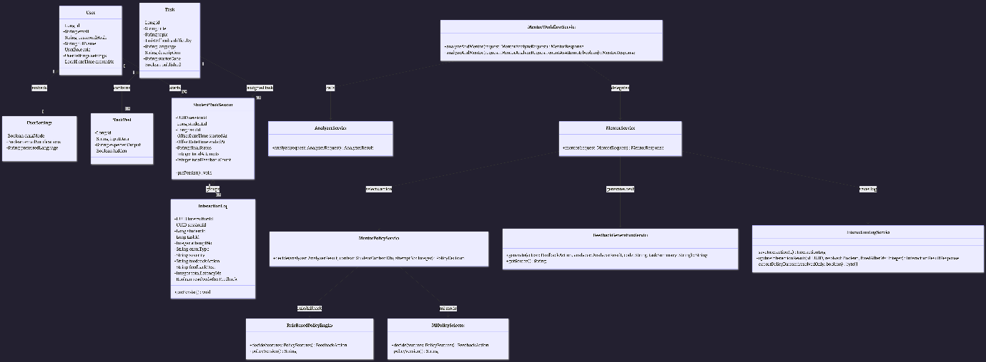

Task 5.2 - Sequence Diagram
User login

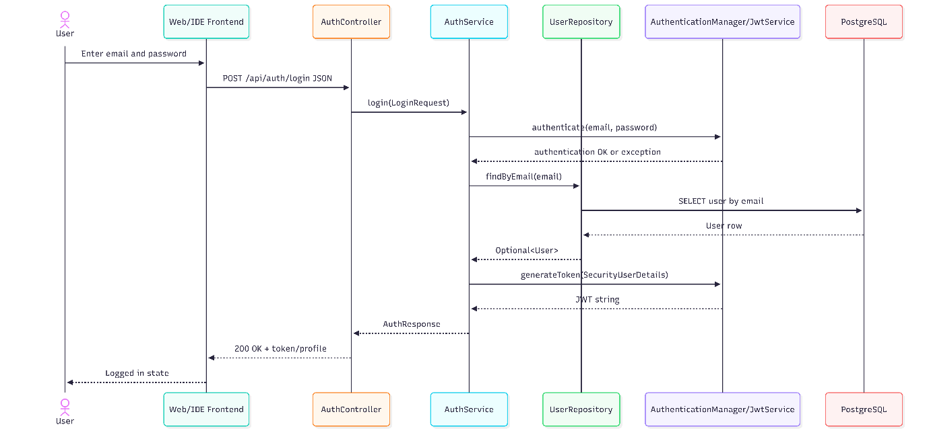

Student Code Submission and Mentor Feedback

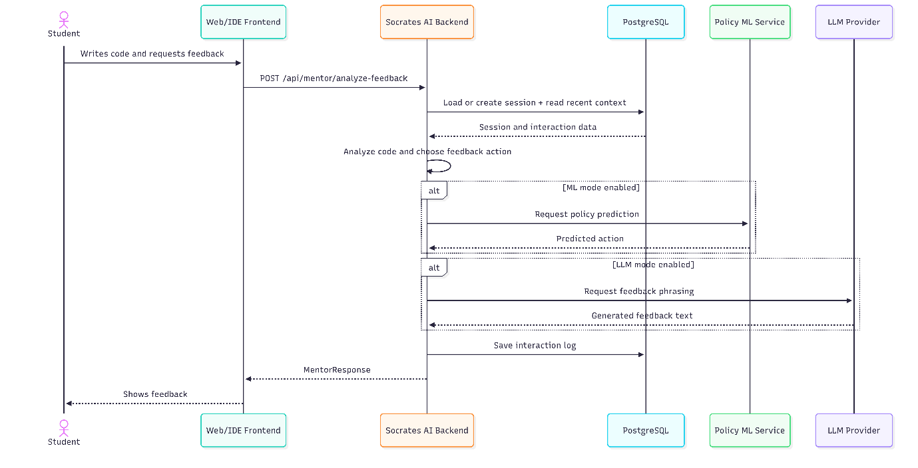

Teacher Creates a Task

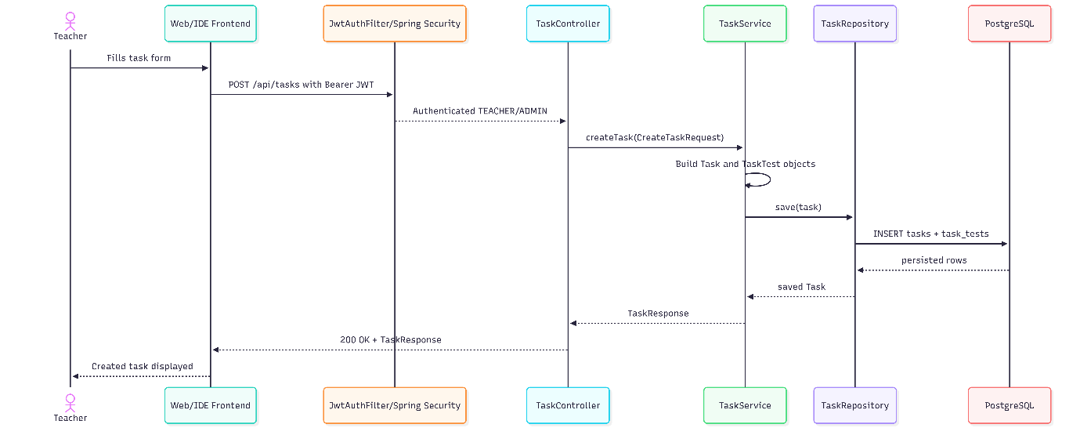

Task 5.3 - Entity-Relationship Diagram
